

**EAST WEST UNIVERSITY**

A/2 Jahrul Islam Avenue, Jahrul Islam City

Aftabnagar, Dhaka-1212, Bangladesh

**Course Title:** Web Programming

**Course Code:** CSE 479

**Semester**: Fall 2022

**Project Name: Organic Orchard**

**Project Members**

|  |  |
| --- | --- |
| **Name** | **Student ID** |
| **Syeda Tamanna Sheme** | **2018-2-60-010** |
| **Md. Mostafijur Rahman** | **2018-2-60-042** |
| **Md. Salem Talukder** | **2018-2-60-077** |

**Course Faculty**

Md Mohsin Uddin

Senior Lecturer

Department of Computer Science and Engineering

East West University

**Table of Contents**

**Section 1:** Introduction--------------------------------------------------------------------------------------1

**Section 2:** Model View Controller Diagram (MVC Diagram) ----------------------------------------4

**Section 3:** Non-Functional Requirements-----------------------------------------------------------------5

**Section 4:** Functional Requirements-----------------------------------------------------------------------6

**Section 5:** Technologies-------------------------------------------------------------------------------------9

**Section 6: Git History** -------------------------------------------------------------------------------------10

**Section 7:** Unit Test Code----------------------------------------------------------------------------------13

**Section 8:** Debugging---------------------------------------------------------------------------------------19

**Section 9:** GUI Screen Shot--------------------------------------------------------------------------------19

**Section 10:** Future Plan------------------------------------------------------------------------------------ 33

**Section 11:** Conclusion-------------------------------------------------------------------------------------34

# **SECTION 1: Introduction: Problem Definition, Motivation, and Challenges**

1. **Introduction**

This document's main goal is to give a thorough overview of our software product, including its specifications and objectives. The target audience, user interface, and hardware and software specifications for the project are all specified in this document. By precisely outlining the problem statement, this document intends to collect, analyze, and provide an in-depth insight into the entire online grocery product Selling, Buying, payment, and gaining an idea about grocery products. This paper contains a list of all the specific requirements for the Organic Orchard.

* 1. **Problem definition**

By putting buyers and sellers in one location, we are automating the supermarket bazaar. Dealers can add information about their grocery products. There is also a preview of all required features. Customers can search for any product based on the features they need. Users can examine customer reviews and reputation updates for the dealer. We also include a "about us" and "contact us" page so that people can learn more about us, get in touch with us, and share their opinions about our products. Users can save time and money by using this website.

The purpose of this document is to describe the requirements for users to buy and sell grocery products. Our project Organic Orchard includes dealing between sellers and buyers. Our website has the facility to give a unique id for every user and details of every user and the staff automatically. It includes a search facility to know the current status of each related website. Users can search availability of a deals-related website using the id. The user can be entered using a username and password. It is accessible either by a seller or buyer. User can enter their requirements, which actually describes what the user wants. The data can be retrieved easily. The interface is very user-friendly. The data are well protected for personal use and make the data processing very fast.

* 1. **Motivation**

The proposed website is Organic Orchard. In order to store the data for later use, the system will be utilized to collect information from the users. The current procedure is a paper-based procedure. It moves too slowly and is unable to give information about current users. The system's goals are to decrease overtime pay and boost the number of users who can receive accurate care. This document contains functional and non-functional requirements statements. We're going to create a project online so that clients can simply find out information about purchasing and selling supermarket items. Additionally, because senior individuals find it difficult to shop offline, they can profit from this service.

The main purpose of this web application is to provide an online grocery showroom and to allow users to book products online. Customers can sign up for this platform and use their login credentials to book products. The administrator is the device's primary operator, and he or she will input personnel and new product information. There are some grocery websites in Bangladesh but the numbers are very low. Because our country is still developing, many individuals are unaware of auto buying and selling methods, as well as which food is best for them based on their budget. Also included are the grocery product System and the online payment and home-delivery system. As a result, our system will assist in resolving all of these issues.

* 1. **Business Model**

We have two main users on our website: general people and admin. Those who register and purchase grocery products three consecutive times on our website will receive a bonus discount. Furthermore, each regular user and customer who take our service will receive free service for the first three sessions. Our system also includes a home delivery service, allowing any user to pay cash on the delivery system. If a customer buys products from our website more than five times, he or she will receive a 2% discount.

* 1. **Challenges**
* In the face of the pandemic, we, those who are responsible to develop the software will not able to go out and communicate with different people to see what potential users may actually want from this system. So, all we were able to do is brainstorm and decide on as many features as we can to include in this system.
* This software system is quite a large project. We were able to brainstorm a lot of features that we wanted to include in this project. However, due to the limited number of team members and limited time, we will not be able to include all the possible features in this system before the project deadline.
* The language and framework that are going to be used are fairly new to us, the software developers. So, it will take some time for the team members to get familiar with the new language and framework used, that is PHP.
* We have to make sure that the user interface is not too technical so that all the users find it easy to use.
* Since this project is entirely team-driven, we lack any client or upper-management feedback. Lacking well-defined client requirements will make the development process a little more difficult.
* Our team members are eager to work in a professional environment. This leads us to use a Version control system such as Git. Our team members are unfamiliar with it but we will try our best to exploit all the functionalities Git can offer.
* Furthermore, we would like to create an API to improve the reusability of our developed codes.

# **SECTION 2: Model View Controller (MVC)**

# 

**SECTION 3- Non-Functional Requirements**

**3.1. User-Friendly Interface**

The software system’s user interface (UI) is made as user-friendly as possible so that all the users can easily use the system. The user interface is intuitive. All new web users are able to complete our website registration without any difficulties.

**3.2. Hardware Interface**

The hardware has the ability to read the profile of sellers and buyers, assistance is given wherever users need it, ability to access multiple modes.

**3.3.  Interface with modern design**:

Not only the user interface is friendly but also it has a modern design. Besides, our website is responsive for any device. Users can use it on their mobile, tab, laptop, or desktop very easily.

**3.4.  Security and Privacy**

We focused on website privacy and security. There is no way to misused user data in any way. So, the privacy of the users is protected at all costs and the software has a secure system. Users' accessibility is censured in all ways. Users are advised not to share their passwords with anyone.

**3.5. Maintenance**

The website is designed in such a way that changes can be made easily. Only admins are allowed to connect the website for maintenance.

# **SECTION 4: Functional requirements: Detailed Scenario-Based Description**

**4.1. Sign up and Registration:** There are two types of users who can sign up and register in this software system. Based on the type of user, information needs to be entered:

**General Users:** General users can create an account, log in, or log out from the website. They can also see the home page, contact us, and about us section. Also, users can buy and order. They can view their shopping basket, make a payment, and check the status of their order and payment.

**Scenario:** A person comes and tries to sign up as a General user. He or she needs to enter the following information:

* + - Full name
    - Email Address
    - Password
    - Confirm Password
    - A photo

**Admin:** All product updates, payment confirmations, and user confirmations are accessible to admins. An admin can create several admins. When the website was created, administrators were formed. It generates itself. An admin can also create an admin from the database. For making an admin, the admin needs to change the user-type table in the database, and after that, a user will also become an admin. Thus, the admin is not required to register. Only the admin is able to log in directly.

**Scenario:** Admin needs to give the following information for registration:

* + - Full name
    - Email Address
    - Password
    - Confirm Password
    - A photo

**4.2. User Verification during Sign up or log in:**

Whenever users register in this system, the admin will verify the user, and only then will the users have full access to all the features of the system.

**Scenario-1:** User tries to sign up for the first time:

The user will first need to state what type of user he or she is. Then, according to the type of user, he or she needs to enter all the required information. Verification of users is done on the basis of the user type:

**Scenario-1(a):** What happens when the user enters a username, and password with which a user is already registered?

* The user can not register since the same username, and password for two users will not be allowed.

**Scenario-1(b):** What happens when the user enters a unique phone number, username, and password?

* The user is successfully registered into the software system.

**Scenario-1(c):** What happens when a user successfully enters all the valid information?

* The user must be verified by the admin and only then they will be allowed to access the rest of the user-specific features.

**4.3. User Verification During Login:**

Whenever a verified user tries to log in, the system will check whether the correct username and password are entered.

**Scenario 2:** If a user tries to log in, he needs to enter his username and password. The system will then verify if the user really exists:

**Scenario-2(a):** What happens if the entered username and password are valid?

* If the username and password are valid, the user can access other user-specific features.

**Scenario-2(b):** What happens if the entered username and password are not valid?

* If the username and password are not valid, he will not be allowed to access the user-specific features and will be asked to enter the correct information again.

**4.4. User-Specific Features - Buy:**

On our website, customers can select and purchase things. Vegetables, fruits, meat, and fish are the four primary groups into which the products are subdivided. Users can add products to their cart, choose a product from the cart, delete a product from the cart, or confirm a specific product. Customers may purchase products in any number.

**4.5. User-Specific Features - Order:**

**4.6. User-Specific Feature - Cart:**

**4.7. User-Specific Feature - Profile:**

Car related problems like parts repair, car insurance, battery replacement, oil change, car buying, car buying idea, car selling idea all problems solutions are provided through our expert. But for getting an idea and gaining all the information the users have to register in our website.

**4.8. User-Specific Feature – Contact Us and About Us**

**4.9. Free Roaming Scenarios:** Even if a user is not logged in, he or she will have the option to freely roam the site, visit others profile to see if anyone is eligible for donation or visit some created posts.

**4.10. Admin Features:**

**4.11. Car Listing and Car Finding Page:**

Users will find information and pricing criteria for automobiles, as well as other information, on the car listing and car finding pages.

**4.12. Other Required pages:**

A page must be prepared where people can read about the software and its stakeholders (About us page). Also, a separate page must be prepared listing all the contact information (Contact us page).

# **Section 5: Technologies - Programming Language, Database, Others**

* **Programming language:** The programming language that is used in the backend of this software system is PHP. It is one of the most popular and widely used programming languages in the world.
* **Database:** For the database, MySQL is used to store all the information. MySQL is a relational database management system (RDBMS) based on Structured Query Language (SQL). MySQL is renowned for being the most secure and reliable database management system used in web applications. Not only this, MySQL can be relied upon to make high-performance websites to ensure optimum speed.
* **Frontend:** For the front end, Bootstrap, HTML, and CSS are used to make the website responsive and mobile-first. So, users can access all features on all devices. JavaScript is also used to make the website interactive.
* **IDE/Editor:** Sublime Text, Visual Studio.
* **Version Controlling System:** Git.

**Section 6: Debugging**

Debugging is an essential part of software application development. To remove the faults and make the application clean debugging process is very much required. If bugs are present in the application, it can drastically affect app performance and may even cause freeze and crash. While developing our project on VS Code, which has a number of automated debugging tools were at our disposal. But we did not essentially rely on those tools. We simply tried to understand what is happening in each line of code when facing difficulties. We also use the console panel to check and modify the code. The Browser Console is like the Web Console but applied to the whole browser rather than a single content tab. So, it logs the same sorts of information as the Web Console - network requests, JavaScript, CSS, security errors and warnings, and messages explicitly logged by JavaScript code.

# **Section 6: Git History**

# **Section 9: GUI Screenshot**

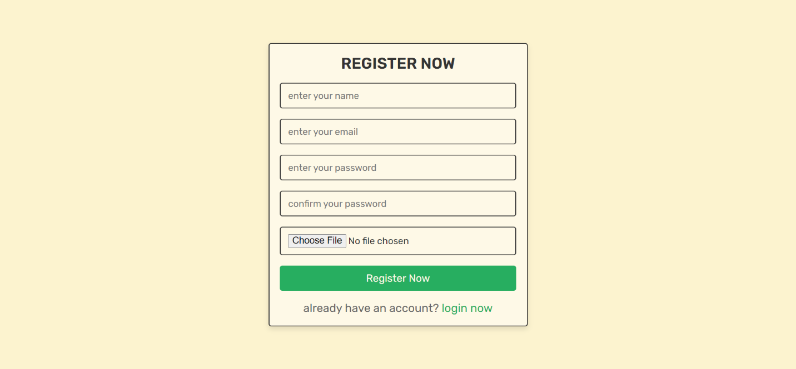

**GUI Screen Shot: Car Cloud Home Page**

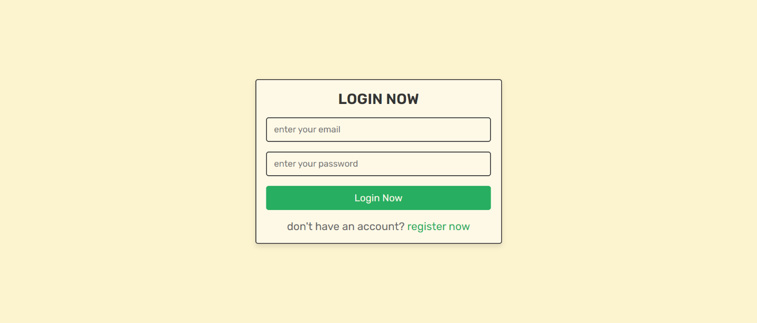

**GUI Screen Shot: Admin Home Page**

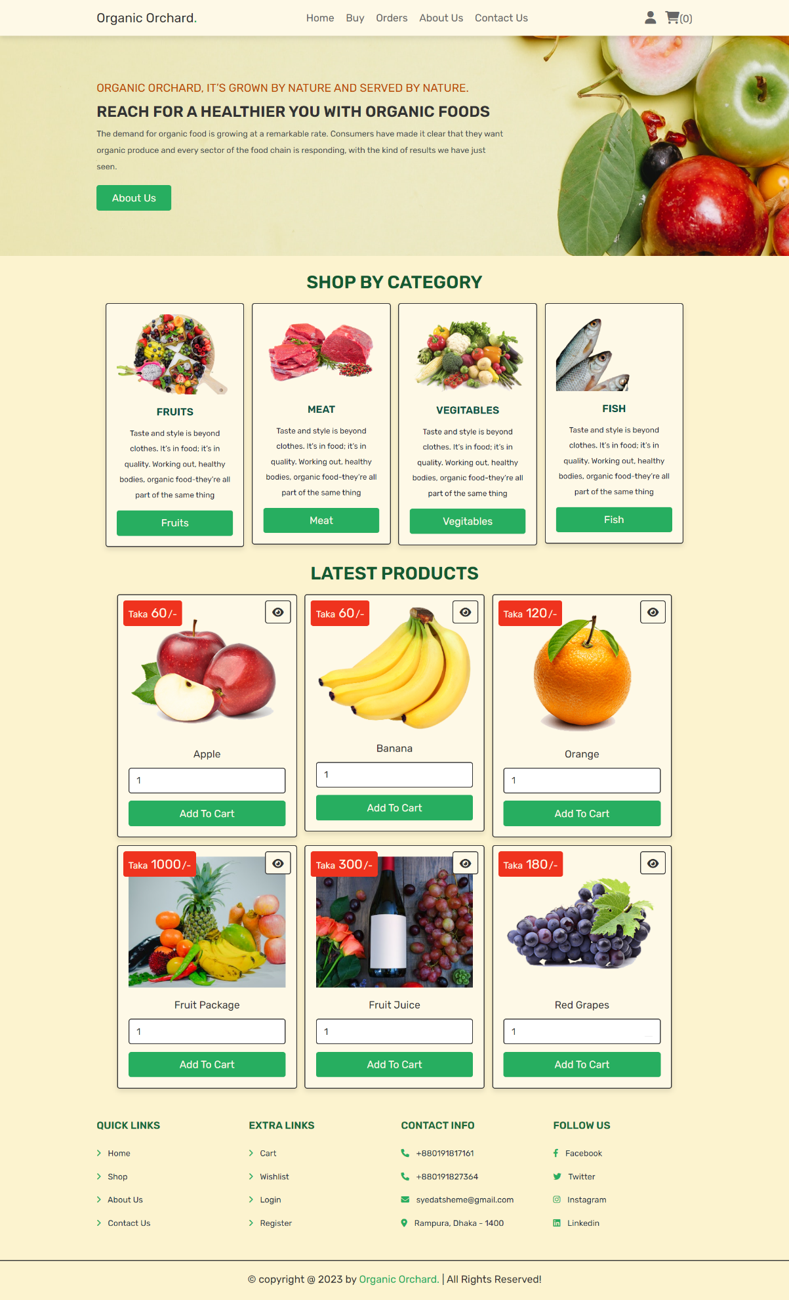

**GUI Screen Shot: Frequently Ask Question Page**

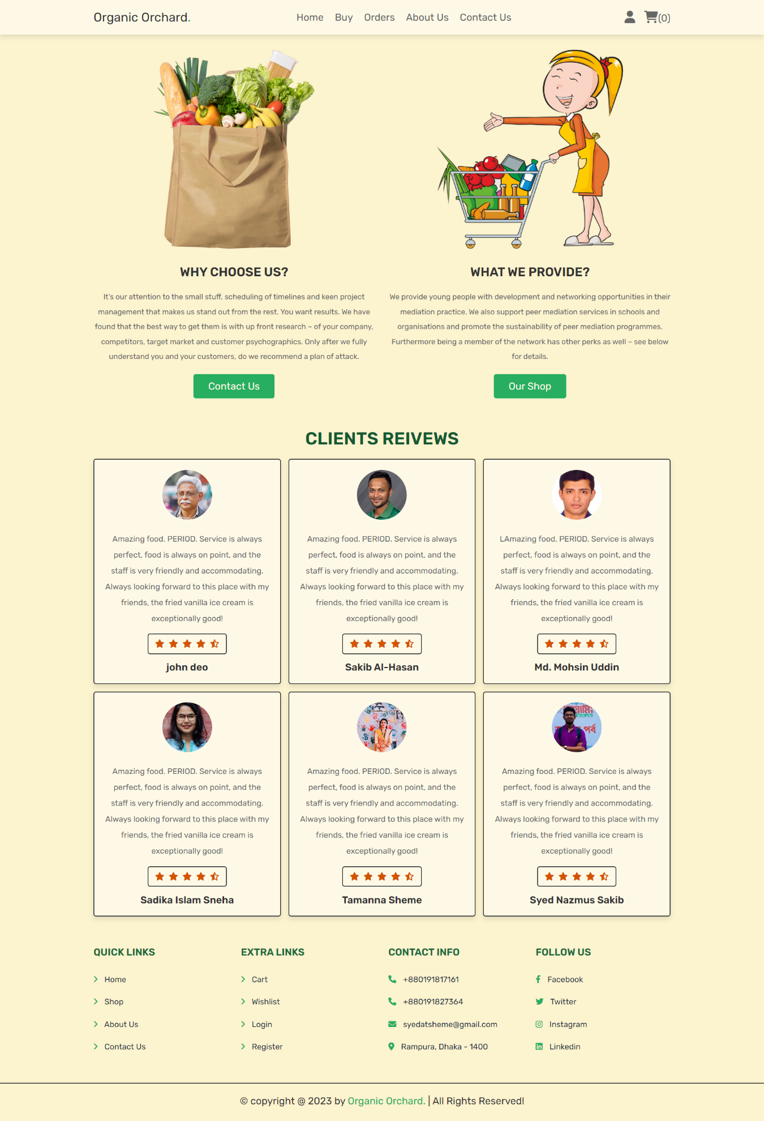

**GUI Screen Shot: About Us Page**

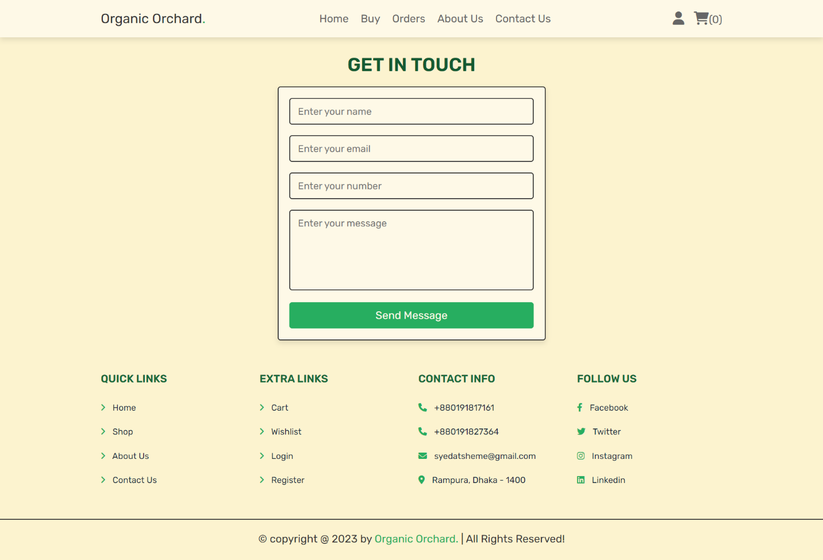

**GUI Screen Shot: Login Page**

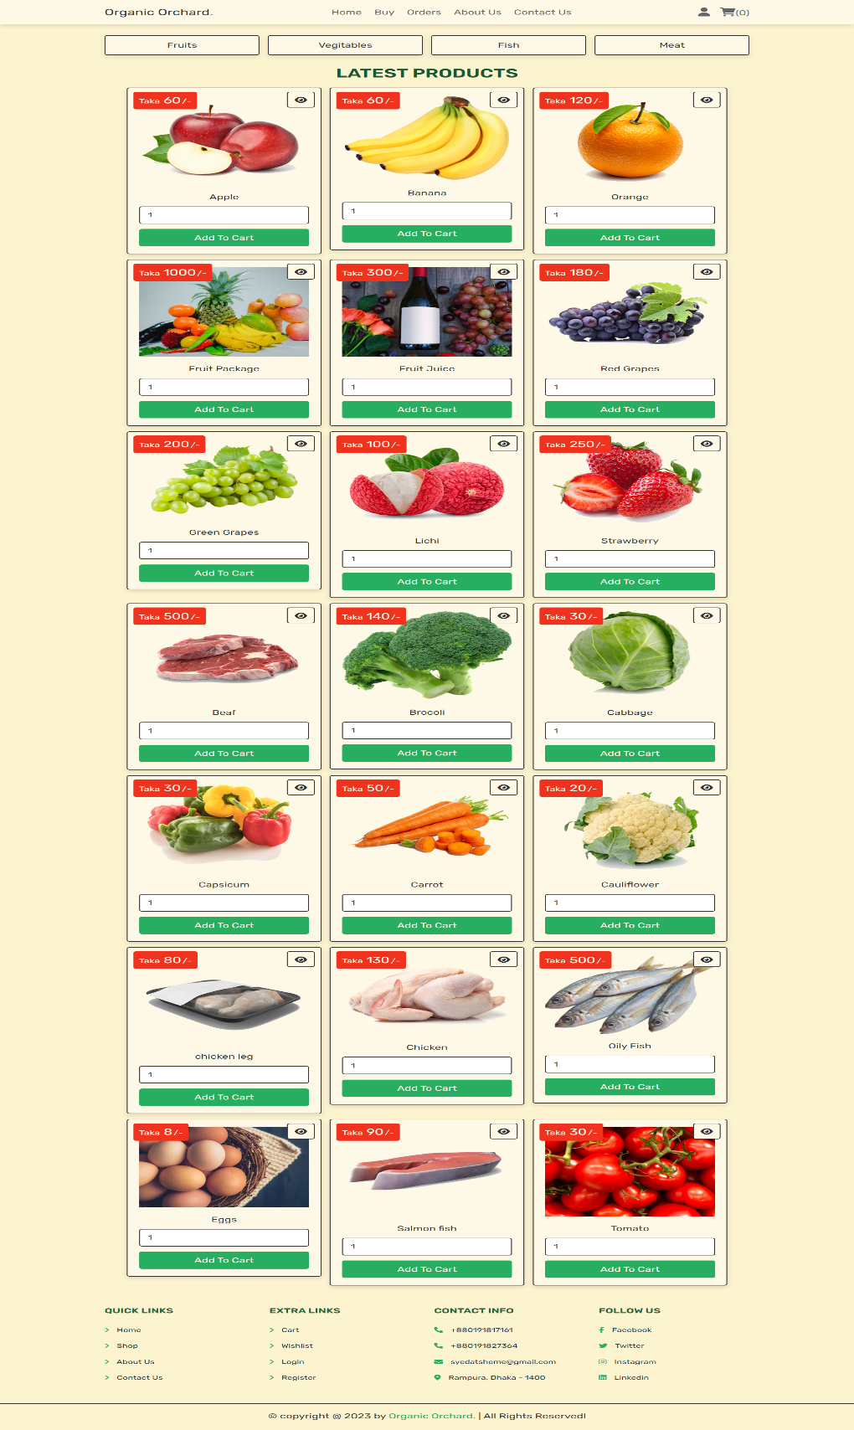

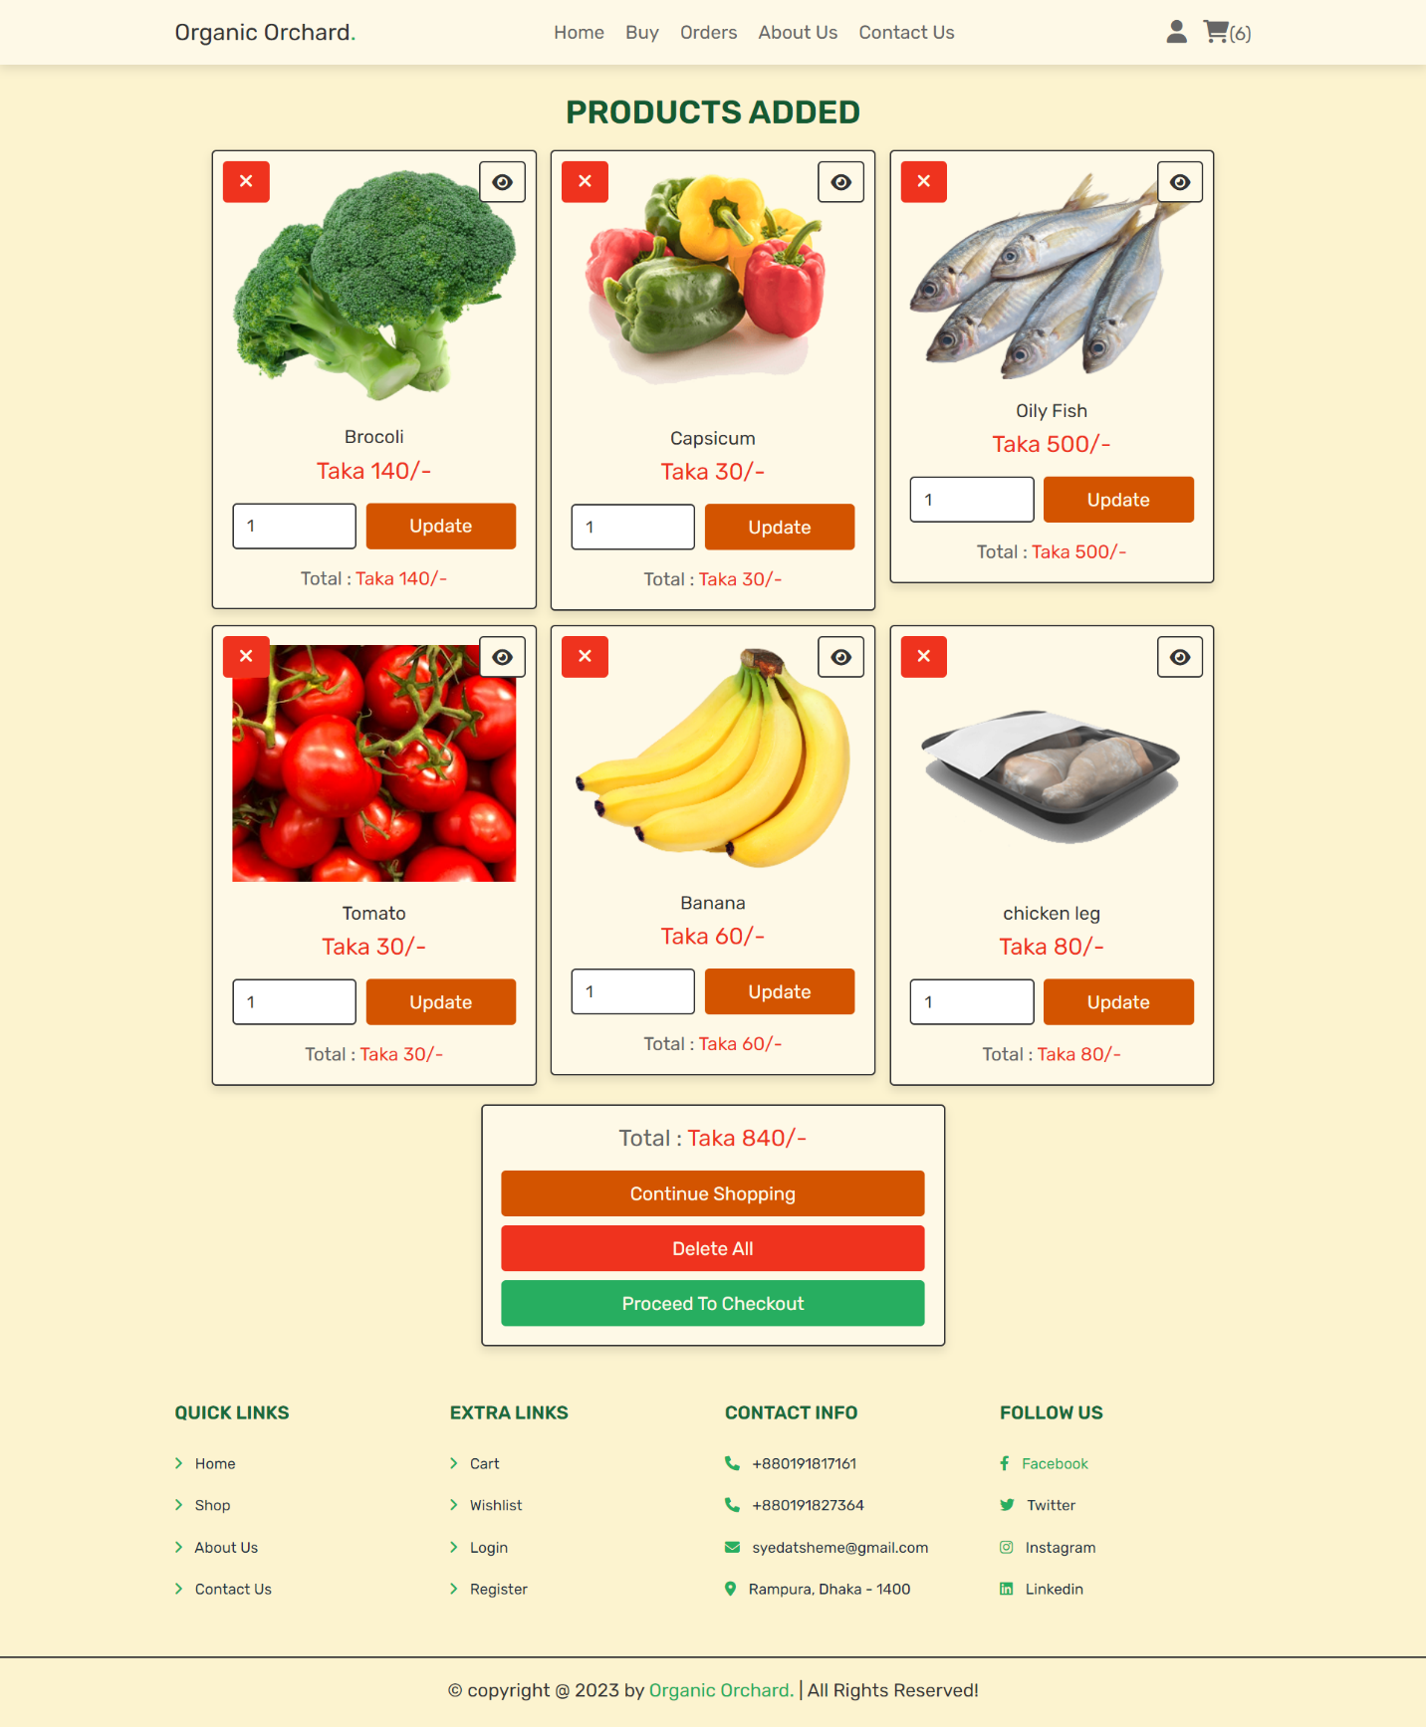

**GUI Screen Shot: Sign Up Page**

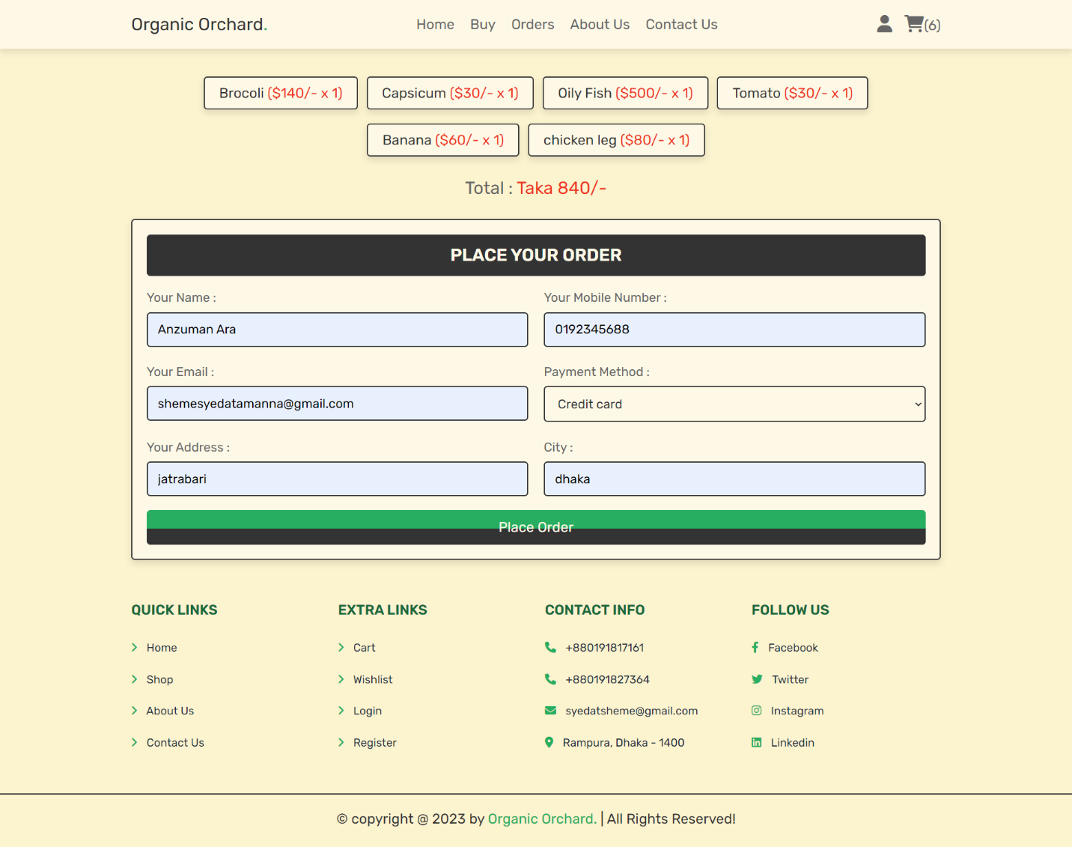

**GUI Screen Shot: Contact Us Page**

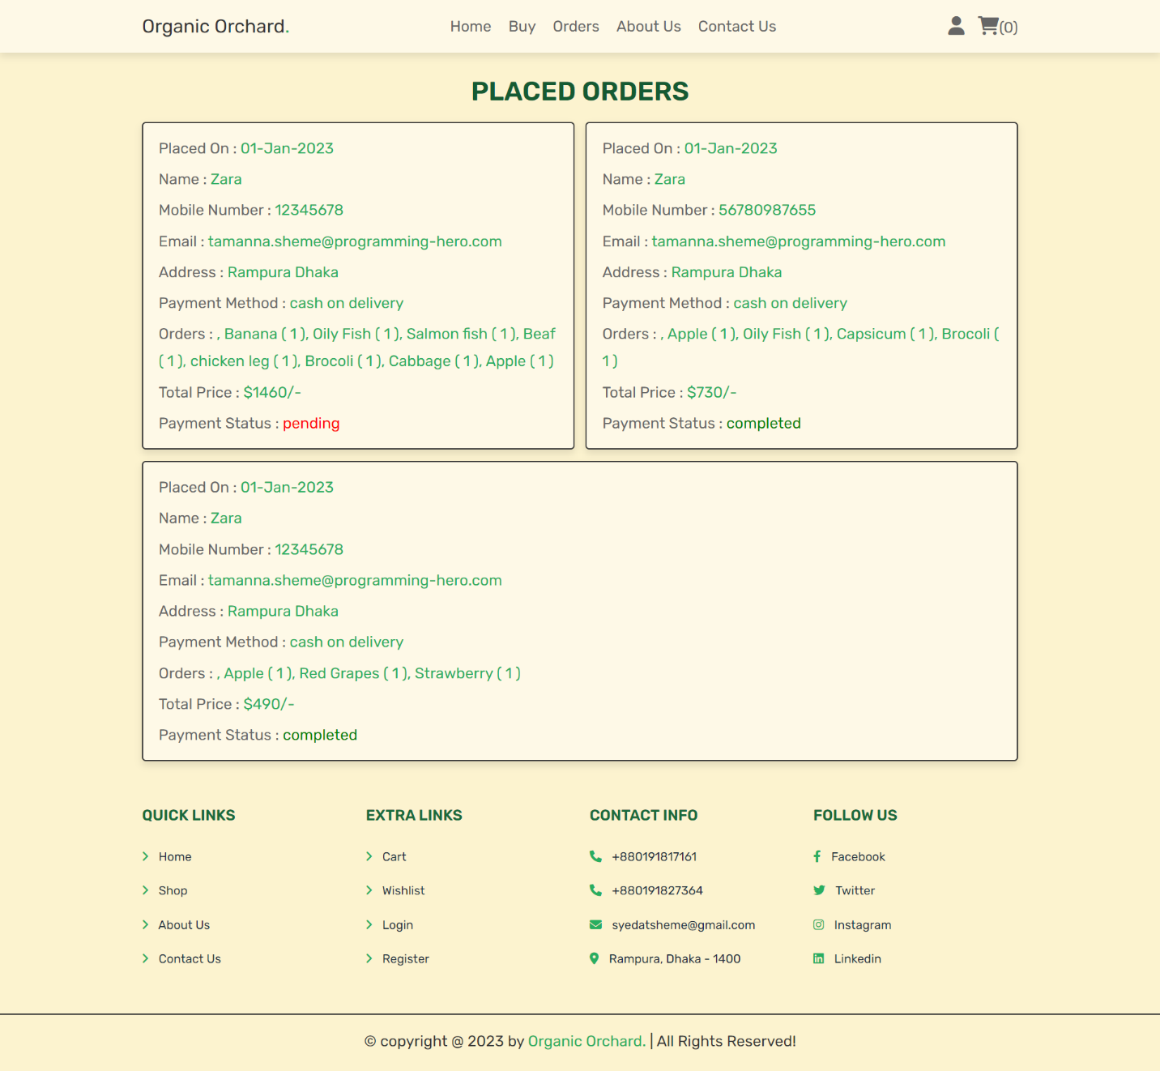

**GUI Screen Shot: Car Listing Page**

**GUI Screen Shot: Car Listing Description Page**

**GUI Screen Shot: Profile Page**

**GUI Screen Shot: My Booking Page**

**GUI Screen Shot: My Comments Page**

**GUI Screen Shot: Admin Dashboard Page**

**GUI Screen Shot: Admin Password Change Page**

**GUI Screen Shot: Admin Contact Information Change Page**

**GUI Screen Shot: Admin Post a Vehicle Page**

**GUI Screen Shot: Admin Manage Brand Page**

**Section 10: Future Plan**

* We love the UI as it is but we think it can be improved so that the users can navigate more easily and smoothly. That is why we will work on the UI and make it perfect
* Some limitations are there while customizing profiles, creating posts, and interacting with others’ posts. We would like to improve user experience by adding a new feature to these actions.
* As of right now there is only one admin and only the admin can post products for the future, we want to add several dealers, who can add their products to our website.
* We would like to add users’ frequently asked questions and other features to make this project a complete grocery store package.
* As of now, this is a web application that can be accessed on any device. But we would like to bring it to a handheld platform by turning it into an android app so that anyone can use it anywhere anytime.

**Section 11: Conclusion**

The project's primary purpose was to reach out to anyone who was looking for buying grocery products. We are optimistic that we will be able to attain our target at this time. Organic Orchard is capable of living up to its title. A website that will provide assistance and support to individuals who are in need. We aspire to provide assistance to anybody, everywhere, and at any time by forming a helpful community.